**LIFE SCIENCES**

**OLYMPIAD EXAMINATION**

**2O22**

1. A fat molecule is saturated if it …

A contains many hydrogen atoms and single bonded carbon atoms.

B contains many hydrogen atoms and at least one double bonded carbon atom.

C contains few hydrogen atoms with many double bonded carbon atoms

D contains few hydrogen atoms with at least a single bonded carbon atom.

Answer: A. Remembering REASON: Saturated fats have large numbers of hydrogen atoms (they are ‘saturated’ with hydrogen atoms) with single bonds and no double bonds

1. The basic structure of two microorganisms is represented in the diagram below.

**Diagram X**

**Diagram Y**

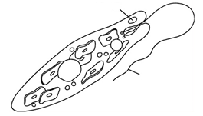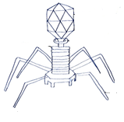

eye spot

sheath

flagellum

Which statement is CORRECT about the two diagrams?

A X is a Protista, Y is a bacterium

B X is a virus, Y is a fungus

C X is bacterium, Y is a virus

D X is a Protista, Y is a virus

Answer: D Understanding Reason: The basic structures of a Protista and a virus.

QUESTIONS 3 AND 4 ARE BASED ON THE INFORMATION ON THE PEDIGREE DIAGRAM BELOW

Duchene muscular dystrophy is a recessive sex-linked genetic disorder that causes muscle weakness. The pedigree diagram below shows the inheritance of the disorder in a certain family.

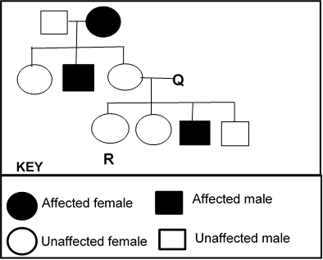

3. The phenotype of individual Q is …

A unaffected male with a dominant allele

B unaffected male with a recessive allele

C affected male with a dominant allele

D affected male with a recessive allele

Answer: A - Applying Reason Since none of the daughters is affected it means Q is not carrying the recessive allele hence he is unaffected male with a dominant allele

4. Using D for the dominant allele of the disorder, the possible genotype of individual R is …

A XDXD or XdXd

B XDXd  only

C XDXD orXDXd

D XdXd only

Answer: C. Applying Reason could be homozygous unaffected

5. Which ONE of the following is TRUE for a person who has an underactive thyroid gland?

The TSH levels will be …

A high and the metabolic rate low.

B high and the metabolic rate high.

C low and the metabolic rate low.

D low and the metabolic rate high.

Answer C Understanding Reason: TSH controls the production of thyroxin by the thyroid. An increase of thyroxin leads to an increase in metabolic rate and vice versa. An underactive thyroid would have a low thyroxin production leading to a low metabolic rate.

6. Which organic compound has the basic structure shown below?

**C**

**C**

**C**

**C**

**O**

**C**

**CH2OH**

**H**

**OH**

**OH**

**H**

**H**

**OH**

**OH**

**H**

A Nucleic acid

B Carbohydrate

C Protein

D Fat

Answer: B Remembering Reason Basic Structural diagram of carbohydrate

7. Any molecule that cells of the immune system specifically recognise as foreign is called …

A antibody

B antigen

C pathogen

D virus

Answer: B Remembering

8. Which combination of the following structures is part of the human male reproductive system:

1. scrotum
2. fallopian tube
3. seminal vesicles
4. ureter
5. testes

A (ii), (iii) and (iv)

B (iii), (iv) and (v)

C (i), (iii) and (v)

D (i), (ii) and (iii)

Understanding: Answer C Reason: The other answers have parts of the female reproductive system and the urinary system.

9. The diagram below shows some body parts in different organisms.

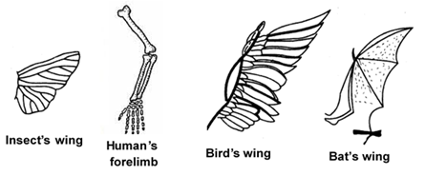

Which ONE of the following pairs is an example of a homologous structure?

A Insect’s wing and a human’s forelimb

B Human’s forelimb and bat’s wing

C Bat’s wing and bird’s wing

D Bird’s wing and human’s forelimb

Answer: B Applying Reason body parts that have similar structures that suggest same origin

10. Grade 10 learners investigated the process of osmosis using the set up as shown in the diagram below.

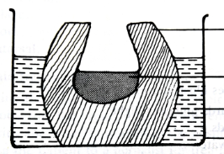

peeled potato

water

salt solution

glass beaker

How will the levels of water and salt solution change after several hours?

A Water and salt solution levels will remain the same

B Water level will increase and salt solution level will decrease

C Water level will decrease and salt solution level will increase

D Water level will decrease and salt solution level will remain the same

Answer C Analysing----Reason In Osmosis water molecules move from a region of more water molecules (water solution) to a region of less water molecules(salt solution) through the semipermeable membrane

11. Which organism is the vector for Malaria?

A Anopheles mosquito

B virus

C Plasmodium parasite

D bacteria

Answer A Remembering Reason: The Anopheles mosquito carries the Plasmodium parasite that infects a person.

12. Which ONE of the following is a consequence if the round window of the ear hardens?

A Pressure waves will not be created.

B Impulses will not be transmitted to the brain.

C Pressure between the outer and the middle ear will not be equalised.

D An echo will occur and the sound will be distorted.

Answer: D Understanding Reason: If the round window hardens it will not be able to prevent the reflection of pressure waves causing ethos.

13. Two red-eyed fruit flies were mated and they produced 150 red–eyed flies and 48 white-eyed flies. From this information we can reasonable conclude that the …

A white-eyed condition is recessive and both parents are heterozygous.

B red-eyed condition is dominant and both parents are red-eyed homozygous.

C white-eyed condition is recessive and both parents are red-eyed homozygous.

D red-eyed condition is recessive and both parents are heterozygous.

Answer A Analysing Reason: Only a cross between two heterozygous fruit flies with white being recessive and red dominant will give rise to a 3 (150) red-eyed:1(48) white eyed ratio. The other answers will not be able to give rise to this ratio.

1. A group of similar cells combined to perform a common function is called …

A organism

B organ

C tissue

D system

Answer C Remembering Reason: Definition of tissue

15. There is a need to reduce solid waste or find ways of managing it. The National Waste Management Strategies have identified the following strategies to reduce solid waste:

(i) Recycling

(ii) Treatment and disposal

(iii) Recovery

(iv) Avoidance and reduction

(v) Re-use

Arrange the strategies in the ascending order of effectiveness using the numbers.

A (iii) 🡪 (i) 🡪 (v) 🡪 (iv) 🡪 (ii)

B (ii) 🡪 (iii) 🡪 (i) 🡪 (v) 🡪 (iv)

C (ii) 🡪 (iii) 🡪 (i) 🡪 (iv) 🡪 (v)

D (i) 🡪 (ii) 🡪 (iii) 🡪 (v) 🡪 (iv)

Answer: B Understanding Reason; avoidance and reduction are the most effective way of reducing waste which pits B and D but (i) is of higher effectiveness than (ii), hence option B is the correct answer

QUESTIONS 16 AND 17 ARE BASED ON THE DIAGRAM BELOW SHOWING HOW THE SKIN BLOOD CAPILLARIES BEHAVE UNDER DIFFERENT ENVIRONMENTAL CONDITIONS, X AND Y. THE ARROWS REPRESENT HEAT LOSS.

epidermis

dermis

blood capillaries

skin surface

**X**

**Y**

16. Under what environmental condition will the skin behave as shown in X?

A Humid

B Hot

C Cold

D Dry

Answer C Applying. The blood vessel constrict/vasoconstriction and less/no heat is heat is lost to the skin surface

17. Which ONE of the following correctly describes the regulation of body temperature in Y?

A Decrease in diameter of blood capillaries, less heat loss and less sweat

B Decrease in diameter of blood capillaries, more heat loss and more sweat

C Increase in diameter of blood capillaries, more heat loss and more sweat

D Increase in diameter of blood capillaries, more heat loss and less sweat

Answer C Applying. Reason Hot condition, blood capillaries dilate, more heat loss and more sweating to cool the temperature.

18. The manufacture of proteins in the cytoplasm using the message brought by the mRNA from the nucleus is …

A translation

B ribosomal RNA

C codons

D transcription

Answer A Remembering Reason the sequence of codons in mRNA determines the sequence of amino acids in a polypeptide

19. The cheek cell in the diagram below is magnified 250 times. The width of the cell is shown by the line X to Y. Measure the width in (mm) and use the equation below to calculate the actual width of the cell.

Actual width = image size

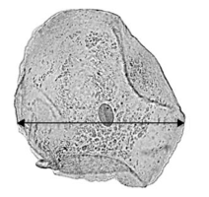

**Y**

**X**

Magnification

A 0,10 mm

B 0,12 mm

C 0,14 mm

D 0,16 mm

Answer C Understanding Reason XY= 35 mm (range 34 to 36). if substituted in the equation gives the correct answer

20 The graph below shows the concentration of solutes in the fluid in the different regions of a nephron from the human kidney. Curve R shows the concentration in the presence of the hormone ADH. Curve S shows the concentration in the absence of ADH.

Curve R

ADH present

Curve S

ADH absent

First convoluted

tubule

Loop of Henle

Concentration of the solutes in the fluid in the different regions of a nephron

ADH absent

Concentration of solutes in fluid in nephron

Second

convoluted

tubule

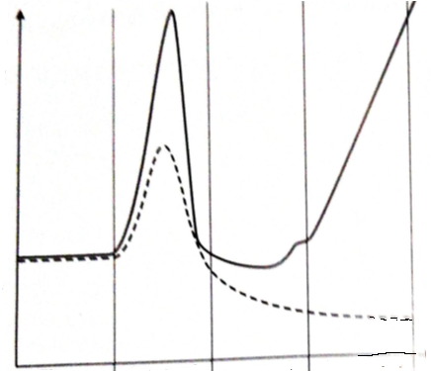

Collecting duct

Which ONE of the statements explains the difference in concentration of the fluid in the collecting duct in curves R and S?

|  |  |  |
| --- | --- | --- |
|  | **Curve R** | **Curve S** |
| A | Permeability of collecting duct decreases | Permeability of collecting duct increases |
| B | Larger volume of more dilute urine produced | Smaller volume of more concentrated urine produced |
| C | Larger volume of more dilute urine produced | Smaller volume of more dilute urine produced |
| D | Smaller volume of more concentrated urine produced | Larger volume of more dilute urine produced |

Answer D Analysing. Reason: In curve R, ADH increases permeability of the walls of collecting duct, more water is reabsorbed, smaller volume of more concentrated urine produced: In curve absence of ADH makes walls impermeable to water, larger volume of more dilute urine produced.

21. From the phylogenetic diagram below which statement is CORRECT?

**T**

**Present**

**P**

**Q**

**R**

**S**

**U**

A Species U, T and S are extinct but species P, Q and R are existing

B Species Q and R are more closely related than they are to species S

C Species T is the common ancestor of all the other species

D Species Q and R share a less recent common ancestor than the common ancestor they share with S

Answer B Analysing. All the other statements are false

22. The table below shows the number of new TB cases recorded in 1994 and in 2004 from four different geographical regions in the world. These data exclude people who are HIV positive.

|  |  |  |  |  |
| --- | --- | --- | --- | --- |
| Year | Number of new TB cases per 100 000 of the population | | | |
| Africa | Asia | Europe | South America |
| 1994 | 148 | 629 | 48 | 98 |
| 2004 | 281 | 535 | 104 | 59 |

Describe a trend shown by the data between the two years.

A Increase in number of new cases in Africa and Europe

B Increase in number of new cases in Asia and South America

C Decrease in number of new cases in Asia and Europe

D Decrease in number of new cases in Africa and Europe

Answer A Analysing The other distractors do not match

1. The CORRECT pathway of oxygenated blood from the lungs to the heart and to all the parts of the body is …

A Pulmonary artery 🡪 left atrium 🡪 left ventricle 🡪 aorta

B Pulmonary vein 🡪superior vena cava 🡪 right atrium 🡪 pulmonary artery

C Inferior vena cava 🡪 right atrium🡪 right ventricle 🡪 pulmonary artery

D Pulmonary vein 🡪 left atrium 🡪 left ventricle 🡪 aorta

Remember Answer: D Reason: the parts of the other pathways do not connect with each other.

QUESTIONS 24 AND 25 ARE BASED ON THE DIAGRAM BELOW SHOWING THE MAJOR GROUPS OF THE KINGDOM PLANTAE.

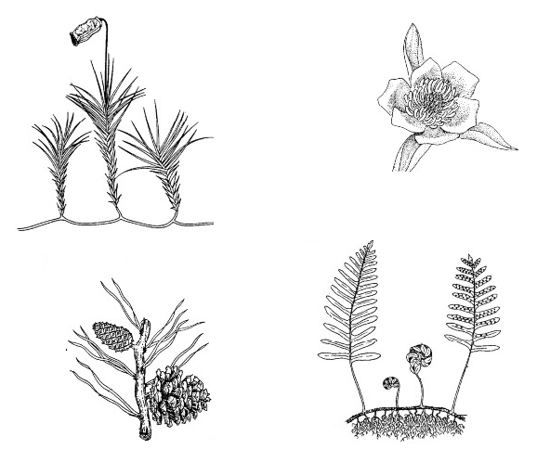

**P**

**Q**

**R**

**S**

24. In which group are members having the following characteristics?

* Lack specialised vascular tissue
* Have dominant gametophyte
* Fertilisation requires an outside source of moisture
* Often found in moist locations

A P

B Q

C R

D S

Answer A Applying. The characteristics related to only bryophytes.

25. The correct sequence in terms of INCREASING dependence on water for reproduction in the members of the diagram is …

A P🡪 Q 🡪 R 🡪 S

B Q 🡪 S 🡪 R 🡪P

C R 🡪 P 🡪 S 🡪 Q

D S 🡪 R 🡪 Q 🡪P

Answer B Applying Reason The others are mixed up with some showing sequence in terms of decreasing dependence.

26. Scientists collected frogs from three different provinces in South Africa. They wanted to find out if the frogs from the three populations, X, Y and Z belong to the same species. They put the frogs together for a long time.

The diagram below shows the results of their investigation.

Produced infertile offspring

**Y**

Produced infertile offspring

Produced fertile offspring

Could not interbreed

**Z**

**X**

We can conclude that …

A All three populations are of the same species

B populations X and Y are of the same species but populations X and Z are different species

C populations Y and Z are same species but populations X and Z are different populations

D Populations X and Y are same species but Y and Z are different species

Answer C Analysing Correct definition of species

27. The out of Africa hypothesis is supported by fossil evidence among others.

Which ONE of the following is CORRECT fossil evidence to support the hypothesis?

A *Ardipithecus* and *Australopithecus* fossils have been found in Africa and other parts of the world

B Fossils of *Homo habilis* have been found in Africa

C The oldest fossils of *Homo sapiens* have been found in Africa

D The youngest fossils of *Homo erectus* have been found in Africa

Answer C Understanding *Homo sapiens* fossils are found elsewhere in the world but the oldest has been found in Africa showing it originated from Africa.

28. A researcher has discovered two species of mice that live in the same location. In the lab he is able to generate a viable hybrid by combining gametes from each species, however, no such hybrids exist in the wild.

Which ONE of the following methods of reproductive isolation might explain this phenomenon?

A Infertile offspring

B Species- specific courtship behaviour

C Habitat isolation

D Breeding at different times of the year

Answer D Applying The other distractors do not explain the phenomenon

1. Which ONE of the following shows the correct placement of the carbohydrate in the table below?

|  |  |  |  |
| --- | --- | --- | --- |
|  | MONOSACCHARIDE | DISACCHARIDE | POLYSAHHARIDE |
| A | sucrose | glucose | starch |
| B | galactose | lactose | cellulose |
| C | cellulose | starch | galactose |
| D | glucose | cellulose | lactose |

Answer B Application

30. If 10% of the bases in a molecule of DNA are adenine, what is the ratio of adenine to guanine in the same molecule?

A 1:1

B 4:1

C 1:3

D 1:4

Applying: Answer D Reason: If adenine makes up 10% then thymine also makes up 10% of the molecule. The remaining 80% is made up from guanine and cytosine which is also in a ratio of 1:1. Thus guanine and cytosine both make up 40% of the molecule. Therefore adenine is 10% to guanine’s 40% resulting in a ratio of 1:4.

31. The portion of the Earth’s atmosphere within the biosphere is the …

A ionosphere

B troposphere

C stratosphere

D ozone layer

Remembering Answer – B Reason the correct definition of troposphere

32. Antarctica is a continent of ice. Which combination of the statements below explains why the Antarctica is important to life on Earth?

1. It holds most of the world's fresh water
2. It is a valuable benchmark for Climate Change.
3. Antarctica environment and biosphere comprise highly sensitive indicators of present-day environmental changes.
4. Key drivers of Earth’s oceanic and atmospheric systems
5. Its ice absorbs some of the sun's rays to the Earth

A (i), (ii), (iv) and (v) only

B (i), (ii), (iii) and (iv) only

C (ii) (iii), and (iv) only

D (ii), (iii) and (v) only

Analysing Answer B The Antarctica deflects some of the sun’s rays away from the Earth but here it is stated incorrectly which makes (v) the only incorrect option.

33. In humans, blood returning to the heart from the vena cava goes to the …

A left ventricle

B right ventricle

C left atrium

D right atrium

Answer B Understanding: the correct sequence in circulation

34. Study the following animals:

(i) Spiders

(ii) Snails

(iii) Crabs

(iv) Grasshoppers

Which combination of the animals belong to the phylum Arthropoda?

A (i), (ii), and (iii) only

B (iii) and (iv) only

C (i), (iii) and (iv) only

D (ii), and (iii) only

Answer C Applying Reason Snails are the only ones without jointed appendages

35. If the fossil record has few or no intermediate forms, if there are long periods in which the fossils underwent no morphological change, and if new forms arose very quickly, then evolution of these new forms would be best described as …

A Darwinism

B Punctuated equilibrium

C Lamarckism

D Natural selection

Answer B Applying Shows the characteristics of punctuated equilibrium

36. About 77 percent of South Africa's primary energy needs are provided by …

A sun

B fossil

C hydropower

D wind

Answer B Remembering Reason: South Africa's indigenous energy resource base is dominated by coal which is from fossils of prehistoric plants and animals

37. Which biome in South Africa has the highest biodiversity?

A Savanna

B Tropical Forest

C Fynbos

D Nama Karoo

Remembering : Answer A Reason: Tropical forest in South Africa is very small but it has the highest biodiversity of any terrestrial biome. It has an emergent layer of tall trees over 40 metres tall, an over-story of trees up to 30 metres, a sub-canopy layer of trees and tall shrubs and a ground layer of herbaceous vegetation.

38. Study the list of bones below:

(i) Skull

(ii) Sternum

(iii) Humerus

(iv) Scapula

(v) Vertebral column

Which combination of bones are components of the axial skeleton in humans?

A (i), (ii) and ((iii) only

B (iii), (iv) and (v) only

C (i), (iii) and (iv) only

D (i), (ii) and (v) only

Answer D Remembering. Correct components of the axial skeleton. The rest are components of the appendicular skeleton.

39. Which ONE of the following shows the CORRECT sequence in human nutrition?

A Ingestion 🡪 digestion 🡪 absorption 🡪 assimilation 🡪 egestion

B Digestion 🡪 Ingestion 🡪 absorption 🡪 assimilation 🡪 egestion

C Ingestion 🡪 digestion 🡪 egestion 🡪 assimilation 🡪 absorption

D Ingestion 🡪 assimilation 🡪digestion 🡪 absorption 🡪 egestion

Answer A- Understanding Reason The normal way of the digestive tract functioning

40. Which statement would most likely be in agreement with Lamarck’s theory of evolution?

A Brown locusts have evolved in an area because they were better adapted to the environment and had high rates of survival and reproduction.

B Most variations in animals and plants are due to gene mutations.

C Geographical barriers may lead to reproductive isolation and a production of a new species.

D Mice without tails will evolve because the tails of the mice of many previous generations were cut off.

Analysis Answer D Reason: The mice have no tails because the tails of their ancestors were cut off and this trait was passed on to the offspring is the statement most likely to be in agreement with Lamarck’s theory of evolution. Lamarck’s theory of evolution included a principle, use and disuse.

41. The table below shows four characteristics Bongi and Naidoo gave about themselves.

|  |  |  |
| --- | --- | --- |
|  | BONGI | NAIDOO |
| W | I am a girl | I am a boy |
| X | I am 160 cm tall | I am 158 cm tall |
| Y | I can roll my tongue | I cannot roll my tongue |
| Z | My blood type is AB | My blood type is B |

Which statements describe the characteristics of discontinuous variation?

A W, X, and Y only

B X, Y and Z only

C W, Y and Z only

D Z, X and W only

Answer C Applying Reason Discontinuous characteristics are discrete, Only X is continuous.11

42. Which ONE of these is a TRUE statement?

A Reduction of fossil fuel burning will enhance the greenhouse effect

B Reduction of fossil fuel burning will lessen the greenhouse effect

C Global warming is so imminent that nothing can be done

D Global warming is of no immediate concern

Answer B Understanding Reason Gives the correct effect on global warming

43. Which ONE of the sequences of the cell cycle is CORRECT?

A prophase 🡪 metaphase 🡪 interphase 🡪 telophase 🡪anaphase

B interphase 🡪 anaphase 🡪 telophase 🡪 metaphase 🡪 prophase

C interphase 🡪 prophase 🡪 metaphase 🡪 anaphase 🡪 telophase

D prophase 🡪 anaphase 🡪 interphase 🡪 metaphase 🡪telophase

Answer C Understanding the correct sequence of cell division

44. Biologists classify animals according to body symmetry.

The diagram below shows different animals with various symmetries.

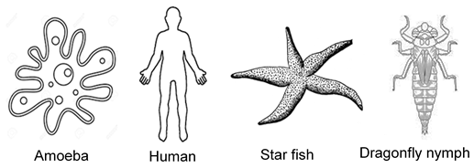

Identify which ONE of the following shows the correct symmetry of the organisms.

|  |  |  |  |  |
| --- | --- | --- | --- | --- |
|  | **AMOEBA** | **HUMAN** | **STAR FISH** | **DRAGONFLY NYMPH** |
| A | Bilateral | Radial | Asymmetry | Bilateral |
| B | Asymmetry | Bilateral | Radial | Bilateral |
| C | Radial | Asymmetry | Bilateral | Radial |
| D | Asymmetry | Bilateral | Radial | Asymmetry |

Answer B Applying Reason the body shapes correctly determine the symmetry

QUESTIONS 45 AND 46 REFER TO THE INFORMATION AND THE DIAGRAMS BELOW.

Some learners investigated tropisms in plants. The learners:

- Planted seeds until short shoots had grown

- Covered parts of some of the shoots with black plastic

- Placed the shoots in light coming from one direction

- Put boxes over the shoots to keep out other light

The diagrams below show how the investigation was set up.

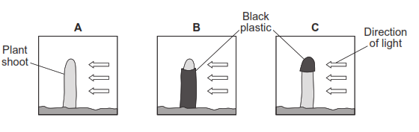

Two days later the learners took off the black plastic covers and observed the shoots.

The diagrams below show the results but in no specific order.

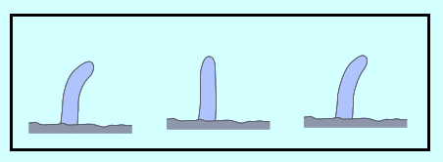

**1**

**2**

**3**

**3**

**2**

**1**

45. Which ONE of the following is the CORRECT matching of the investigative diagrams A, B and C and the results 1, 2 and 3?

A B for 3 only

B A for 1 only

C B for 1 only

D C for 2 only

Answer D Analysing. Reason A and B are for either 1 or 3

46. Name the type of growth movement the learners were investigating.

A Tropism

B Geotropism

C Phototropism

D Thigmotropism

Answer C Remembering Shoot bend towards the unilateral source of light

47. When homozygous, a particular allele of a locus in rats causes abnormalities of the cartilage throughout the body, an enlarged heart, slow development and death. This is an example of …

A polygenic inheritance

B pleiotropy

C epistasis

D codominance

Answer B - Applying Reason shows the ability of a single gene to have multiple effects

48. Which combination of these are characteristics of all animals?

(i) Heterotrophic

(ii) Advanced nervous system

(iii) Reproduction

(iv) Photosynthetic

A (i), (ii) and (iii) only

B (ii), (iii) and (iv) only

C (i), (iii) and (iv) only

D (i), (ii) and (iv) only

Applying Answer A analysing Reason: Animals are not photosynthetic

49. Which ONE of the following cells are closely associated with sieve tubes?

A Vessels

B Tracheids

C Parenchyma

D Companion cells

Answer D Understanding Reason Sieve tubes are found in companion cells

QUESTIONS 50 AND 51 ARE BASED ON THE FOLLOWING INFORMATION AND DIAGRAM.

A coelom is a body cavity surrounding the digestive system. It provides a space for internal organs and can serve as a hydrostatic skeleton.

The diagram below shows different types of body cavities.

ectoderm

mesoderm

endoderm

**Diagram Q Diagram R Diagram S**

50. Which ONE of the following shows the CORRECT identification of each diagram?

|  |  |  |  |
| --- | --- | --- | --- |
|  | Q | R | S |
| A | Pseudo coelomate | True coelomate | Acoelomate |
| B | True coelomate | Acoelomate | Pseudo coelomate |
| C | Acoelomate | Pseudo coelomate | True coelomate |
| D | True coelomate | Pseudo coelomate | Acoelomate |

Answer D- Applying Reason D is the correct identification based on of the diagrams

51. Flatworms (phylum Platyhelminthes) are …

A acoelomate and have bilateral symmetry

B pseudo coelomate and have radial symmetry

C acoelomate and have radial symmetry

D pseudo coelomate and have radial symmetry

Answer A- Applying Reason: the correct characteristics of a Flatworms.

52. The use of living things to make or change products or processes to satisfy human desires is referred to as …

A Recombinant DNA technology

B Genetic modification

C Cloning

D Biotechnology

Answer D Understanding. Reason the correct definition of biotechnology

53. Which ONE of the following statements is a hypothesis?

A Will increasing my cat’s food increase her weight?

B Increasing my cat’s food will result in an increase in her weight.

C I will feed my cat more food to increase her weight.

D Increasing my cat’s food increased her weight

Analysis Answer B Reason: a hypothesis is a statement that emerge from a question. A is an investigative question whose answer will be formulated into a hypothesis C and D are conclusive statements.

54. The graph below shows the effect of temperature on two enzymes, X and Y functioning in two different organisms.



At what temperature do the two enzymes have the same amount of activity?

A 40 0C

B 45 0C

C 52 0C

D 85 0C

Answer B Applying Where the two graphs cross each other

55. The diagram illustrates pupillary reflex.



**F**

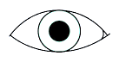

**E**

Which ONE of the following conclusions is CORRECT?

A Diagram E is viewing in bright light, the pupil is dilated

B Diagram E is viewing in dim light, the pupil is dilated

C Diagram F is viewing in bright light, the pupil is dilated-

D Diagram F is viewing in dim light, the pupil is constricted

Answer B Applying Reason in dim light the diameter of the pupil increases and in bright light the diameter of the pupil decreases.

56. When a plasmid carries recombinant DNA into a recipient cell, the process …

A reduces genetic diversity

B is always dangerous

C allows production of proteins difficult to obtain by ordinary means

D requires that the donor DNA and the recipient cell be of the same species

Understanding Answer C Reason the correct way of manipulating DNA of other species to obtain a gene on demand

57. What is the role of nitrogen-fixing bacteria in the nitrogen cycle?

A They change ammonium to nitrate

B They return nitrogen (N2) to the atmosphere

C They change nitrogen (N2) in the atmosphere to ammonium

D They withdraw nitrate from the soil

Answer C Understanding Reason - convert atmospheric N2 into nitrogen compounds in the soil

58. Which ONE of the following organelles contains its own DNA and plays an important role in converting food energy into usable cell energy.

A Golgi apparatus

B Mitochondria

C Endoplasmic curriculum

D Ribosomes

Remembering Answer B Reason: The mitochondria is one of the cell organelles that have their own DNA called Mitochondrial DNA and their main function is to supply cells with ATP (a source of chemical energy) from glucose.

59. The following descriptions refer to one of the biomes in South Africa:

* The largest biome
* Altitude varies from sea level to 2000 m
* Average rainfalls of 230 mm to 1000 mm
* Almost every major geological soil type occurs
* Well developed over the Low-veld and Kalahari region

Which biome in South Africa can be described as above?

A Grassland

B Savannah

C Fynbos

D Forest

Answer B Remembering Reason: Its the largest biome

60. Study the descriptions below:

(i) Conversion of solar energy to chemical energy occurs

(ii) Carbon dioxide is a raw material

(iii) The light-dependent stage occurs in the grana of the chloroplast

(iv) The light-dependent stage occurs in the stroma of the chloroplast

(v) Oxygen is a by-product

Which combination is CORRECT for photosynthesis?

A (i), (ii), and (iii) and (v) only

B (i), (iii), (iv) and (v) only

C (ii), (iii) and (iv) only

D (i), (ii), (iii), and (iv)

Answer A -Understanding (iv) is the only false description

61. Which sequence below is CORRECT with regard to the passage of light through the eye to form an image on the retina?

A cornea → conjunctiva → lens → vitreous humour → retina

B conjunctiva → cornea → lens → aqueous humour → retina

C conjunctiva → cornea → lens → vitreous humour → retina

D cornea → lens → vitreous humour → aqueous humour → retina

Answer C Understanding Reason the correct path through which light rays pass

62. Study the list of Mendel’s laws below:

(i) Principle of segregation

(ii) Principle of independent assortment

(iii) Law of dominance

In a cross between a red-eyed fruit fly and a white-eyed fruit fly, all the F1 offspring were red eyed. Which of the laws of Mendel can be used to explain this results?

A (i), (ii) and (iii)

B (ii) only

C (i) and (iii) only

D (ii) and (iii) only

Answer C Applying (ii) affects dihybrid crosses

63. A male with small testicles, long legs, wide hips, enlarged breasts, sparse body hair, and less muscular most likely has …

A Down syndrome

B Jacobs syndrome

C Turner syndrome

D Klinefelter syndrome

Remembering Answer D Reason: Males who have Klinefelter syndrome have small testes, small penis and enlarged breast.

64. The offspring of better adapted individuals are expected to make up a larger proportion of the next generation.

The most likely explanation is …

A natural selection

B Gene flow

C Mutation

D Genetic drift

Answer A Analysing Reason nature selects suitable characteristics and they reproduce to produce the next generation. Those with unfavourable characteristics die out.

65. Study the food chain: Grass🡪 rabbits 🡪 snakes 🡪 hawks.

Which statement is TRUE according to the food chain?

A Each population is omnivorous

B Each predator population has a greater biomass than its prey population

C Snakes are primary consumers

D Each prey has a greater biomass than its predator population

Answer D- Understanding There is always a loss of energy as it is being transformed from one form/level to another

66. The most common food digested in the human stomach is …

A nucleic acid

B carbohydrate

C protein

D fat

Answer C Remembering Reason pepsin and trypsin, protein digestive enzymes occur in the stomach to start protein digestion

67. The TWO main functions of pancreas are …

A to produce bile and detoxifies the blood

B to remove poisons and to produce pepsin

C contains endocrine glands that controls blood sugar and exocrine glands that help with digestion

D contains exocrine gland control blood sugar and endocrine glands that help in digestion

Remembering Answer C Reason: Produces insulin and pancreatic enzymes

68. The study of human evolution is termed as … …

A palaeontology .

B palaeoanthropology

C paleothermomether ---

D parthenocarpy

Remembering Answer B Reason: The correct definition of palaeoanthropology

69. Barr bodies are …

A genetically active X chromosomes in males.

B genetically inactive X chromosomes in females.

C genetically active Y chromosomes in males

D genetically inactive Y chromosomes in males.

Remembering Answer B Reason: The Barr body is an inactive X chromosome in human females.

70. Trends in the evolution of plants include all of the following EXCEPT …

A from homospory to heterospory.

B from less to more reliance on water for their life cycle.

C from nonvascular to vascular.

D from non-woody to woody.

Understanding Answer B Reason: Plants evolved from a watery to a terrestrial environment. Answers A, C and D are all trends to be able to survive a terrestrial environment. To survive a terrestrial environment there must be less dependence on water for its life cycle and not the other way round.

71. Grade 10 learners investigated the rate of transpiration. They cut 4 leaves of the same size from the same plant and coated one or both surfaces with grease to prevent transpiration. The leaves were left in the laboratory for six hours.

The table below shows the results:

|  |  |  |  |  |
| --- | --- | --- | --- | --- |
| Leaf number | 1 | 2 | 3 | 4 |
| Surface coated with grease | None | Upper only | Lower only | Both |
| % decrease in mass | 50 | 46 | 6 | 4 |

Using the results, explain, from which surface does most transpiration happen?.

A Most transpiration happens from the upper surface only as coating the upper surface caused water loss similar to coating no surface at all

B Most transpiration happens from the lower surface as coating the lower surface caused water loss similar to coating both surfaces

C Most transpiration happens from the upper surface only as coating the lower surface caused water loss similar to coating both surfaces

D Most transpiration happens from the lower surface as coating the upper surface caused water loss similar to coating no surface at all

Answer B Analysing This shows the lowest % decrease in mass meaning if the lower surface is covered little or no transpiration occurs but if not covered as in leaf 2 most transpiration happens.

72. The final digestion products of starch, lipids and proteins respectively are …

A glucose; fatty acids and glycerol; amino acids

B amino acids; glucose; fatty acids and glycerol

C fatty acids and glycerol; glucose; amino acids

D amino acids; fatty acids and glycerol; glucose

Answer A –Remembering The correct absorbable forms.

73. The list below gives the characteristics of some young birds immediately after hatching.

1. Eyes are open
2. Can move around
3. Cannot feed themselves
4. No feathers

Which ONE of the following combinations represents the characteristics of precocial development?

A (ii) and (iii) only

B (iii) and (iv) only

C (i) and (ii) only

D (ii) and (iv) only

Applying: Answer C Reason: The young of precocial birds are relatively mature and mobile from the moment of hatching. What that implies that they must be able to see where they are going and that they must have feathers to be able to fly. They must also be able to feed themselves to have energy to move/fly about.

74. What can be used to treat people with coronary heart disease?

A Vaccination

B Antibiotics

C Stent

D Hormones

Answer C Remembering Reason A coronary artery stent is a small, metal mesh tube that expands inside a coronary artery.  It helps prevent the artery from closing up again.

75. The flow of genetic information in a cell proceeds from …

A RNA to protein to DNA

B DNA to RNA to protein

C protein to DNA to RNA

D RNA to DNA to protein

Answer B Understanding Reason DNA transcribes to give information to mRNA which is translated into protein.

76. The typhlosole within the gut of an earthworm increases the surface area for nutrient absorption. This compares best to which of the organs in humans?

A Teeth in the mouth

B Oesophagus in the thoracic cavity

C Villi in the small intestine

D Rectum in the large intestine none of the above

Applying: Answer C Reason: both the typhlosole and villi increase the surface area for absorption of food in the organ that they are located.

1. A factor that impedes gaseous exchange in the human lung is …

A that the wall of the alveoli is moist.

B that the alveolus is richly supplied with capillaries.

C oxygen is in direct contact with alveolus.

D ruptured walls of the alveoli

Understanding Answer D Reason: damage to the alveoli could hinder oxygen reaching the alveolus whereas all the other answers facilitate gaseous exchange in the lungs.

78. Which of the following pairs of animals are the result of convergent evolution?

(i) Birds and bats

(ii) Eagle and owl

(iii) Snakes and burrowing lizards

(iv) Cats and tigers

(v) Dolphins and sharks

A (i), (iii) and (v)

B (ii), (iv) and (v)

C (ii), (iii) and (iv)

D (i), (ii) and (iii)

Analysing Answer A Reason: Convergent evolution is defined as the process whereby organisms from different groups {e.g. phylum) independently evolve analogous structures that have similar form or functions. (i), (iii) and (v) exhibit these characteristics whereas in each case of the other examples the organisms are from different groups.

79. The Baobab tree in South Africa is …

A invasive.

B indigenous.

C alien.

D foreign

Understanding Answer B Reason: An indigenous tree is native to a given region or ecosystem. The Baobab tree is native to South Africa and was not brought from another place such as certain of the Acacia species plants of Australia that are also invasive as it becomes overpopulated and harms its new environment. The Baobab tree is not invasive.

80. Rusts, ringworm, athlete’s foot and thrush are examples of diseases caused by …

A bacteria

B fungi

C protists

D viruses

Answer B Understanding Bacteria causes cholera and other diseases, virus cause rabies, protist cause malaria. Only fungi cause the listed disease.

81. The diagram below shows a reflex arc

**P**

**N**

**S**

**P**

**N**

**S**

**P**

**S**

**N**

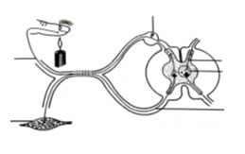

**Q**

**S**

**T**

**P**

**R**

**U**

A person is able to feel pain but cannot react to the stimulus. Give the LETTER and NAME of the neuron that is damaged in this person.

A U- muscle

B T – motor neuron

C Q – cell body

D P –sensory neuron

Answer B Applying Reason conducts message from CNS to the muscle/u to lift up from the stimulus.

82. Which TWO blood vessels carry deoxygenated blood?

A Aorta and pulmonary artery

B Coronary artery and pulmonary vein

C Pulmonary artery and vena cava

D Pulmonary vein and vena cava

Understanding Answer C Reason: it is in the lung and transport waste products. The other blood vessels is either outside of the lungs or transport blood without metabolic waste.

83. The diagram below shows the chromosomes from a sperm cell.

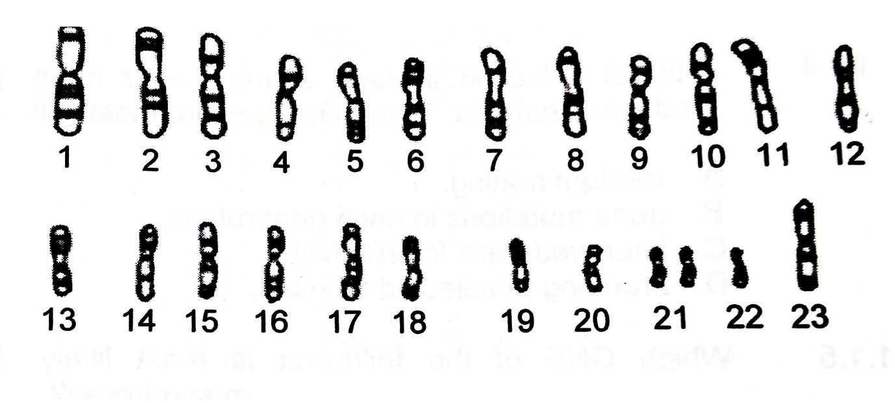

**Karyotype of a sperm cell**

How many autosomes are present in the sperm cell shown?

A 24

B 23

C 22

D 21

Answer C Understanding Reason there are 22 autosomes and 1 sex chromosome

84. Which means of birth control is most effective in preventing sexually transmitted diseases?

A Condom

B Pill

C Diaphragm

D Vasectomy

Understanding A Reason: A condom prevents direct contact between penis and vagina whereas the other birth control methods does not prevent direct contact between penis and vagina which can result in the transmission of STDs.

85. Male moths recognise females of their species by sensing chemical signals called pheromones. This is an example of …

A habitat isolation

B mechanical isolation

C behavioural isolation

D gamete isolation

Answer C- Applying.

QUESTIONS 86 AND 87 ARE BASED ON THE INFORMATION AND GRAPH BELOW.

The graph below shows the results from a resistance investigation in a single population. The same amount of each of three insecticides was used.

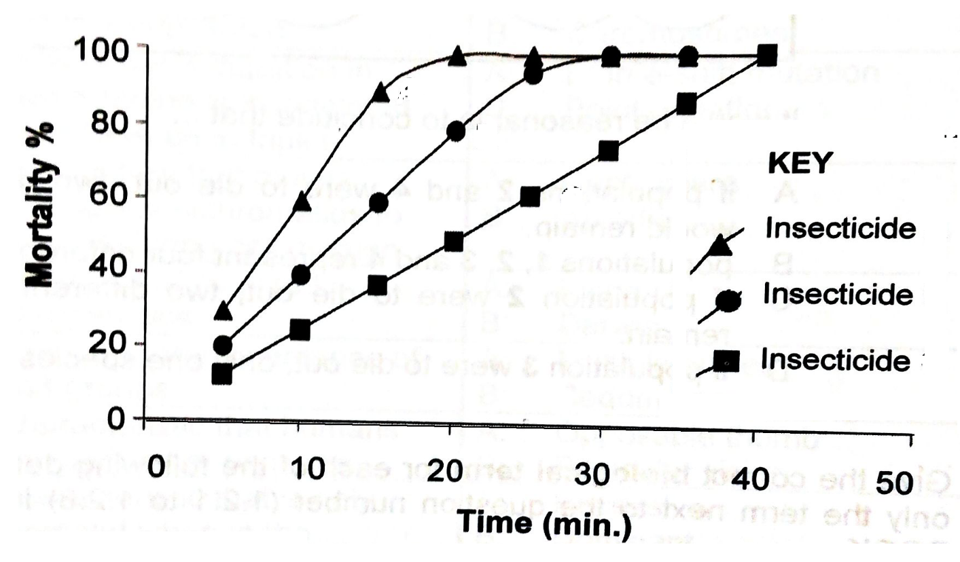

**P**

**Q**

**P**

**R**

**Q**

**R**

86. Which ONE of the insecticides has the slowest killing action, when the same quantity of each insecticide was used?

A Insecticide P

B Insecticide Q

C Insecticide R

D All the insecticides were equally slow

Answer C Applying. Reason, R killed the smallest number of insecticide over the same period of time.

87. We can conclude from the data shown in the graph at 30 minutes that …

A both insecticides P and R have been 100% effective

B both insecticides P and Q have been 100% effective

C both insecticides Q and R have been 100% effective

D all the insecticides have been 100% effective

Answer B Applying Reason, graphs P and Q intersect at 100% mortality at 30 minutes.

88. Kwashiorkor and marasmus are two deficiency diseases caused by malnutrition. The list below are major differences between the two diseases.

1. It is due to deficiency of protein and calories
2. It is due to deficiency of protein
3. Ribs are not very prominent
4. Ribs become very prominent
5. Absence or mild muscle wasting
6. Severe muscle wasting
7. Protuberant stomach
8. No protuberant stomach

Which combination refers to children suffering from kwashiorkor?

A (ii), (iii), (v) and (vii) only

B (i), (iv), (vi) and (viii) only

C (i), (iii), (vi) and (iv) only

D (iv), (v), and (vii) only

Answer A Applying Reason Correct symptoms of kwashiorkor

89. Which is the correct order of embryonic development of the following four stages?

A blastula 🡪 morula 🡪 – gastrula 🡪– organogenesis

B gastrula 🡪– organogenesis 🡪– blastula 🡪- morula

C morula🡪 – blastula 🡪– organogenesis 🡪- gastrula

D morula 🡪– blastula🡪 -gastrula 🡪 - organogenesis

Understanding Answer D Reason: The correct order of embryonic development is that after the ovum is fertilised it undergoes cell division to form a solid ball called a MORULA. The morula then develops into a hollow ball consisting of a single layer of cell surrounding the cavity. This structure is called a BLASTULA. The blastula gives rise to the Gastrula which consists of two or more germinal layers. Lastly, the gastrula undergoes ORGANOGENESIS which is the development of organs. The other answers are not in the right order.

90. The graph below shows maternal serum concentrations of progesterone through gestation.

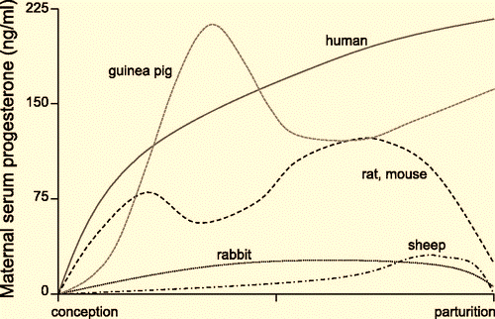

In which of the animals are progesterone levels maintained at a high and increasing concentration throughout parturition?

A Guinea pig and rat only

B Sheep and rabbit only

C Human and guinea pig only

D Human and rat only

Answer C Analysing Reason Only in these are the curves rising towards the parturition end. All the others are decreasing towards the zero mark

91. A horse has eaten 10 kg of biomass in the form of grass, and excreted 6.3 kg in the form of faeces, urine and gas. The increase in its body tissues is 0.4 kg. So how much biomass has been used up in respiration?

A 16,7 kg

B 6,7 kg

C 3,3 kg

D 9,6 kg

Answer C Analysing Reason what is left for respiration is subtracting the biomass lost through excretion and what is used for growth from the total biomass eaten.

92. Working in the Amazon River, a biologist isolated DNA from two unknown organisms, P and Q. He discovered that the adenine content of P was 15% and the cytosine content of Q was 42%. This means that:

A the amount of guanine in P is 15%.

B the amount of guanine and cytosine combined in P is 70%

C the amount of adenine in Q is 42%

D the amount of thymine in Q is 21%

Applying Answer B Reason: In P, adenine was 15%=T. So A+T + C+ G = 100 and C=G. So 15+15 +2G/C = 100. 2G/C = 100 - 30 = 70 thus G+C = 70%

93. Global warming occurs because …

A carbon dioxide and other greenhouse gases react chemically to produce excess heat

B Earth has too many greenhouses and other glassed buildings

C volcanic eruptions produce large quantities of sulphur and other greenhouse gases

D carbon dioxide and other greenhouse gases trap infrared radiation in the atmosphere

Answer D Understanding Reason they don’t allow excess heat to pass out of the atmosphere

94. Which of the following characteristics contribute to power flight in birds?

(i) a light-weight skeleton

(ii) enlarged forelimb

(iii) a keeled sternum

(iv) scales on the legs and feet

(v) homoeothermic

A (i), (ii) and (iii)

B (i), (ii) and (iv)

C (ii), (iv) and (v)

D (iii), (iv) and (v)

Applying Answer A Reason: A light weight to decrease gravitational pull, enlarged forelimb / wing assists flying and keeled sternum makes the bird more aerodynamic to cut through the air.

95. Plants in floodplains often get covered by water during floods. Some plants survive the floods because they can continue photosynthesis underwater. However, the plants’ rates of photosynthesis are much lower underwater than those plants above water.

Which of the following helps to explain why the rates of photosynthesis are lower under water than above water?

A There is too much oxygen in the water.

B There is no carbon dioxide in the water.

C The chloroplast do not function under water.

D The available light is less intense underwater.

Analysing Answer D Reason: The other answers do not happen underwater and the lowering of the light intensity will lower the rate of photosynthesis.

96. A girl is riding a bicycle at high speed around a sharp bend on the road. To prevent herself from falling, she follows the curve of the road. She also maintains her initial speed.

The following are possible changes that take place in the girl’s body to turn the curve:

1. Cerebellum coordinates muscle for proper body movement
2. Cristae detect body’s position in response to movement
3. Maculae determines the position of the body with respect to gravity
4. Cristae detect body’s position with respect to movement
5. Eye determine the movement of the path followed and send impulses to the cerebrum

Which combination will prevent the girl from falling off the bicycle?

A (i), (ii), (iii), (iv) and (v)

B (iii), (iv) and (v) only

C (ii), (iii), (iv) only

D (i), (ii), (iii), (iv) and (v) only

Answer D Analysing- All functions are relevant

QUESTIONS 97 AND 98 REFER TO THE PHYLOGENETIC TREE BELOW.

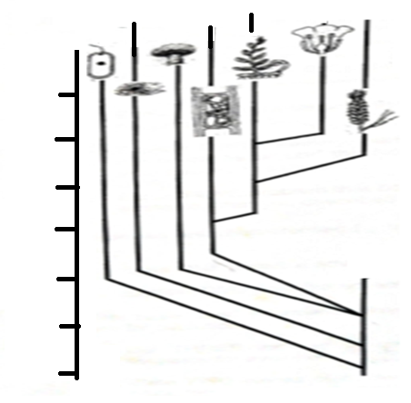

100

200

300

400

500

600

700

0

Bacteria

Protocista

Fungi

Algae

Fern

Flowering plant

Conifers

Millions of years ago (MYA)

97. According to the phylogenetic tree when did the conifers evolve?

A 100 mya

B 200 mya

C 300 mya

D 400 mya

Answer C Understanding Reason corresponds with the appearance of the conifers

98. Which ONE of statement is CORRECT according to the phylogenetic tree?

A The common ancestor of the algae and flowering plant is more recent than that of the ferns and flowering plant

B The Protocista were the first organisms that lived on Earth

C The common ancestor of the ferns and flowering plant is more recent than that of the algae and flowering plant

D Bacteria and Fungi evolved at the same period as ferns.

Answer C Understanding. Reason the common ancestor of flowering plants and algae happened about 380 mya whereas that of ferns and flowering plants occurred about 220 mya

99. The symptoms of a particular disease are:

Fever, dry cough, tiredness, shortness of breath, difficulty breathing, loss of smell or taste, pulmonary embolism, runny nose, sore throat

Which disease associates with these symptoms?

A Bronchitis

B Flu

C COVID 19

D Asthma

Applying Answer C Reason: the diseases A, B and D have certain of these symptoms but not all. Only COVID 19 could possible present with all these symptoms.

100. The following information are of a particular organism:

* Belongs to the order Gruiformes;
* Tall with long legs, necks and bill;
* Omnivore;
* National bird of South Africa;
* Generally brown; grey or white in colour;
* Listed as vulnerable by the IUCN.

Which organism does this information relate to?

A Cape Vulture

B Sugar bird

C Pelican

D Blue Crane

Applying Answer D Reason: the Blue Crane has all these attributes and it is the national bird of South Africa.